Kubernetes Task-1
- Setup Minikube in your local machine.
- Setup k8s master and two worker nodes on ubuntu.
- Run one nginx pod.
- Mugup Master and slave components on k8s.

Task 1 — Setup Minikube on Windows

1. Objective
The objective of this task is to set up a local Kubernetes cluster on a Windows machine using Minikube.
Minikube creates a Kubernetes cluster locally, which allows us to practice:
- Kubernetes Pods
- Deployments
- Services
- Namespaces
- ConfigMaps
- Secrets
- kubectl commands
For this lab, we will use Docker Desktop as the Minikube driver.

2. Architecture
The setup will look like this:
Windows Machine
|
v
Docker Desktop
|
v
Minikube
|
v
Kubernetes Cluster
|
+----------------------+
| |
Control Plane Worker
Components Components
| |
+----------+-----------+
|
NGINX Pod
Minikube normally gives you a single-node Kubernetes cluster, where the same node can perform control-plane and workload roles.

3. Prerequisites
Before installing Minikube, make sure you have:
- Windows 10/11
- Administrator access
- Docker Desktop
- kubectl
- Minikube
We will verify each one.

4. Step 1 — Check Windows Version
Open PowerShell.
Run:
winver
A Windows version window should appear.
You can close it after checking.

5. Step 2 — Install Docker Desktop
Minikube will use Docker as its container driver.
Download and install Docker Desktop from the official Docker website:
Docker Desktop
During installation, keep the default options unless your environment requires something different.
After installation, restart Windows if Docker Desktop requests it.

6. Step 3 — Start Docker Desktop
Open:
Start Menu
↓
Docker Desktop
Wait until Docker Desktop shows that Docker is running.
Then open PowerShell and run:
docker --version
Expected output will look similar to:
Docker version 29.x.x, build xxxxxxx
The exact version can be different.

7. Step 4 — Test Docker
Run:
docker run hello-world
Docker should download the hello-world image and display a successful message.
You should see something similar to:
Hello from Docker!
This message shows that your installation appears to be working correctly.
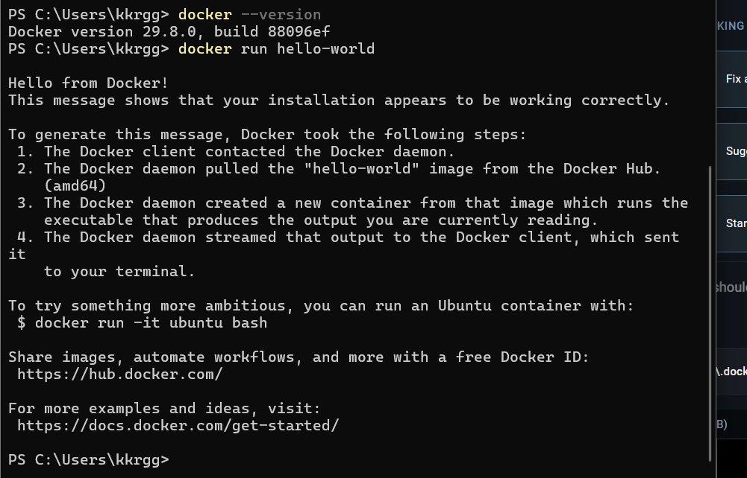

Validation
Run:
docker ps
It is okay if the output is empty because the hello-world container exits after displaying its message.
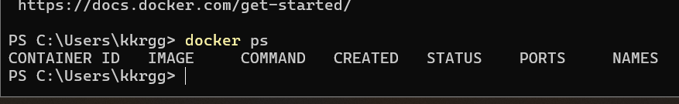
At this point:
Docker
|
+---- Working

8. Step 5 — Install kubectl
kubectl is the command-line tool used to communicate with Kubernetes.
You can install it using the official Kubernetes installation instructions:
Kubernetes — Install kubectl on Windows
After installation, open a new PowerShell window.
Run:
kubectl version --client
Expected:
Client Version: ...
The exact version can be different.

9. Step 6 — Verify kubectl
Run:
where.exe kubectl
You should get a path similar to:
C:\Program Files\Kubernetes\kubectl.exe
or another location where you installed it.
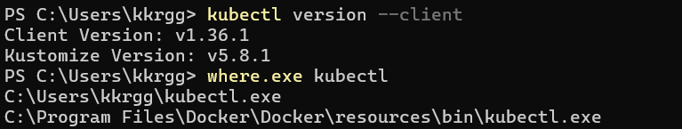
Then:
kubectl version --client
If you get the client version, kubectl is installed correctly.

10. Step 7 — Download Minikube
Now install Minikube for Windows.
Use the official Minikube installation documentation:
Minikube — Get Started
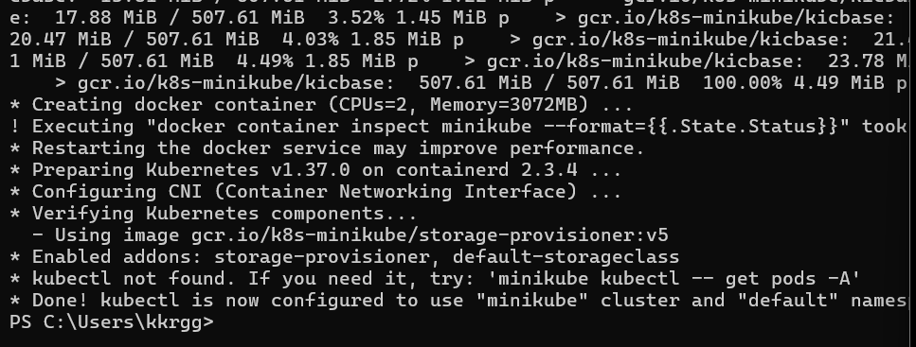
For Windows, install the current Windows executable/package provided there.
After installation, close PowerShell and open a new PowerShell window.
This is important because Windows may need to reload the updated PATH.

11. Step 8 — Verify Minikube
Now run the command that previously failed:
minikube version
The exact version will depend on the current Minikube release.
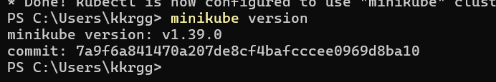

12. If minikube Is Still Not Recognized
If you installed Minikube but still receive:
minikube : The term 'minikube' is not recognized
check whether Windows can find it:
where.exe minikube

If it returns a path
For example:
C:\Program Files\Kubernetes\Minikube\minikube.exe
then Minikube exists, but your current PATH may not have been refreshed.
Close all PowerShell windows, open a new one, and run:
minikube version

If where.exe minikube returns nothing
Minikube is either not installed or its installation directory is not in your Windows PATH.
Do not proceed to minikube start yet. Fix the installation first.

13. Step 9 — Check Minikube Status
Once this works:
minikube version
run:
minikube status
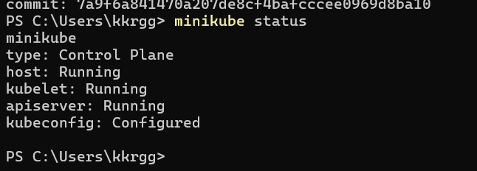

14. Step 10 — Start Minikube
Make sure Docker Desktop is running.
Then run:
minikube start --driver=docker
Minikube will:
- Download required Kubernetes components.
- Create the Minikube node.
- Configure Kubernetes.
- Configure kubectl.
- Start the Kubernetes control-plane components.
- Configure the Docker-based container environment.
The first startup can take several minutes.

15. Step 11 — Check Minikube Status
Run:
minikube status
You should see something similar to:
host: Running
kubelet: Running
apiserver: Running
kubeconfig: Configured
This confirms that Minikube is running.

16. Step 12 — Check Kubernetes Nodes
Run:
kubectl get nodes
Expected output will look similar to:
NAME STATUS ROLES AGE VERSION
minikube Ready control-plane ... v...

The important part is:
STATUS
Ready

17. Step 13 — Check Cluster Information
Run:
kubectl cluster-info
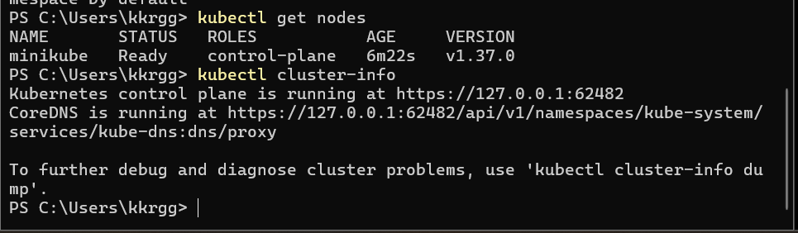
You should get information about the Kubernetes control plane.
This confirms that kubectl can communicate with the Kubernetes API server.

18. Step 14 — Check Kubernetes System Pods
Run:
kubectl get pods -A
The -A means:
--all-namespaces
You should see Kubernetes system components such as:
NAMESPACE NAME
kube-system coredns-...
kube-system etcd-minikube
kube-system kube-apiserver-minikube
kube-system kube-controller-manager-minikube
kube-system kube-proxy-...
kube-system kube-scheduler-minikube
Some additional components may also appear depending on the Minikube version.
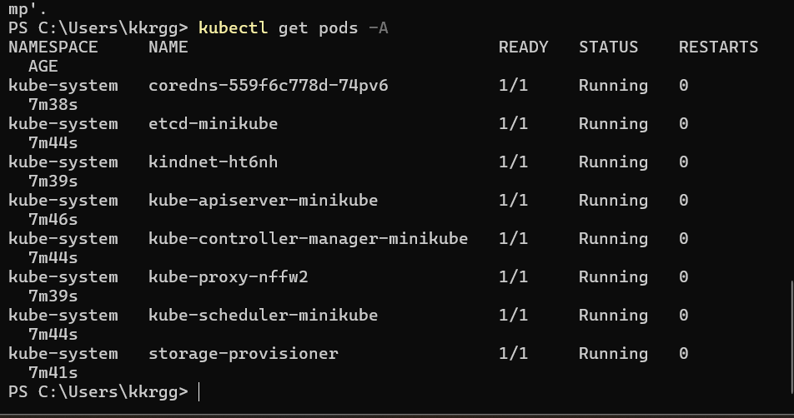

19. Step 15 — Check Minikube Nodes
Run:
minikube node list
You should see the Minikube node.
For example:
minikube 192.168.x.x Running

20. Step 16 — Open the Minikube Dashboard
Minikube provides a Kubernetes dashboard.
Run:
minikube dashboard
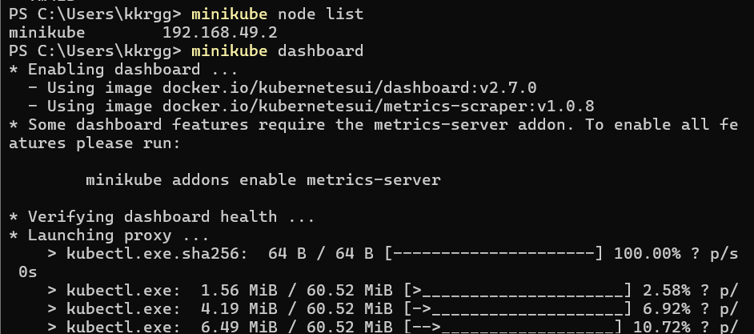
This should open the Kubernetes Dashboard in your browser.
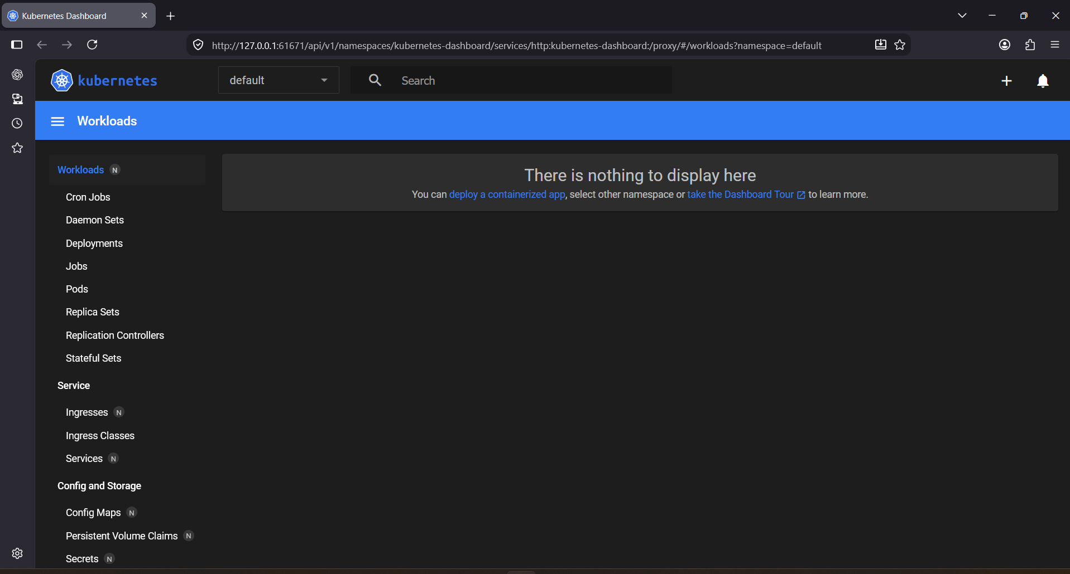
You can use it to visually inspect:
- Pods
- Deployments
- Services
- Namespaces
- Nodes
- Workloads

21. Step 17 — Final Validation
Run all these commands:
docker --version
kubectl version --client
minikube version
minikube status
kubectl get nodes
kubectl get pods -A
Expected overall state:
Docker
|
+---- Working
|
v
Minikube
|
+---- Running
|
v
Kubernetes
|
+---- Node: Ready
|
+---- System Pods: Running

22. Expected Output
The most important validation is:
kubectl get nodes
Expected:
NAME STATUS ROLES AGE VERSION
minikube Ready control-plane ... ...
And:
minikube status
Expected:
host: Running
kubelet: Running
apiserver: Running
kubeconfig: Configured

23. Outcome
After completing Task 1, you will have:
- Docker Desktop installed and working.
- kubectl installed.
- Minikube installed.
- A local Kubernetes cluster running on Windows.
- Kubernetes API Server accessible through kubectl.
- A Ready Minikube node.
- Kubernetes system Pods running.

Task 2 — Setup Kubernetes Control Plane + 2 Worker Nodes on Ubuntu

Objective
Create a Kubernetes cluster with:
- 1 Control Plane
- 2 Worker Nodes
- Ubuntu machines
- kubeadm for cluster creation
- containerd as container runtime

Final Architecture
Kubernetes Cluster
|
Control Plane
Ubuntu Server
|
+----------+----------+
| |
Worker 1 Worker 2
Ubuntu Server Ubuntu Server

Step 1 — Create 3 Ubuntu Machines
You can use AWS EC2 Ubuntu instances for this lab.
Create 3 Ubuntu 24.04 LTS instances.
Machine | Hostname | Purpose
Ubuntu-CP | k8s-master | Control Plane
Ubuntu-W1 | k8s-worker1 | Worker 1
Ubuntu-W2 | k8s-worker2 | Worker 2
For a lab, t3.small is a reasonable starting point if available.

Security Group
Allow at least:
SSH TCP 22
For Kubernetes communication, the three machines must be able to communicate with each other over their private IPs.
For a simple lab, you can allow the Kubernetes nodes to communicate with each other using the VPC/private network.
Do not expose the Kubernetes API port 6443 to 0.0.0.0/0. Allow it only from the Kubernetes nodes/your required network.
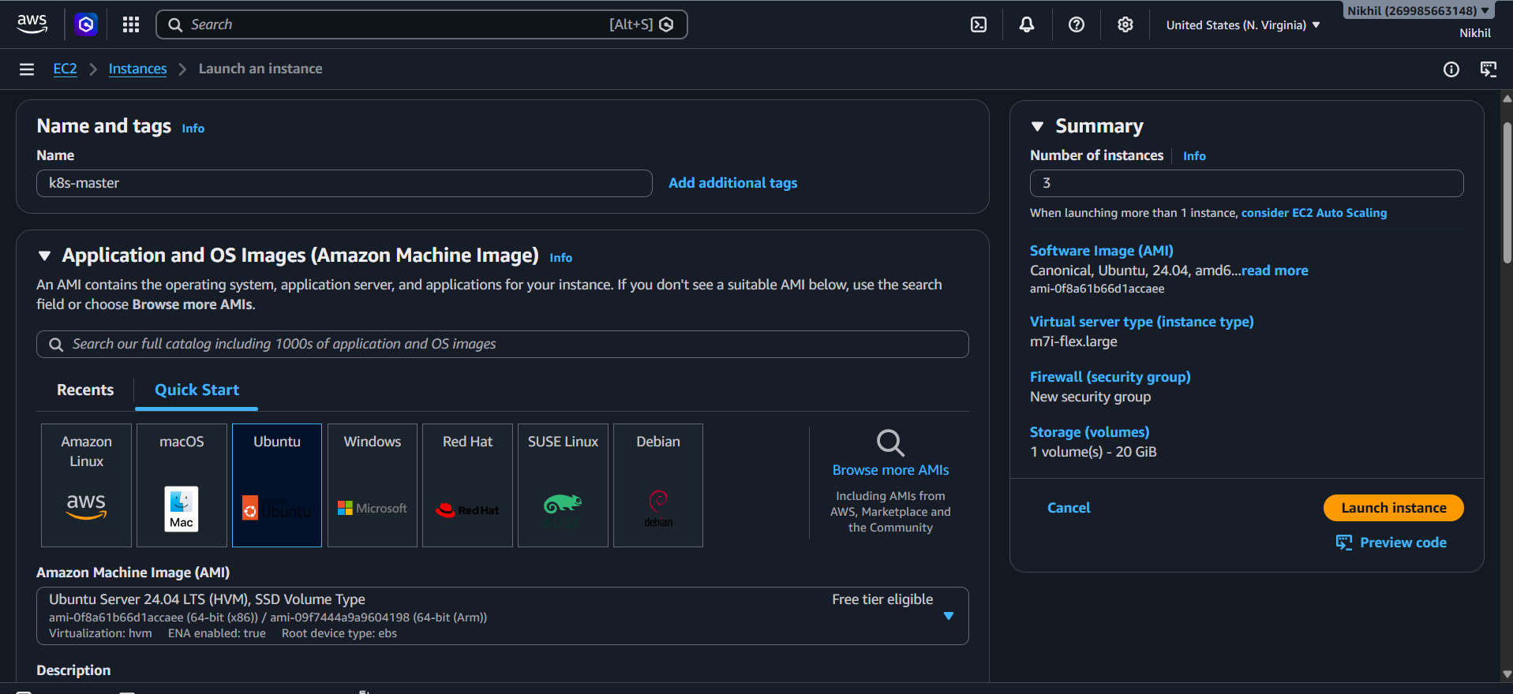
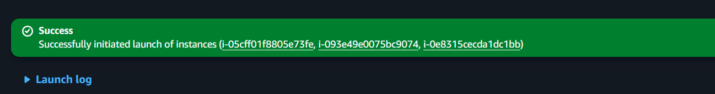
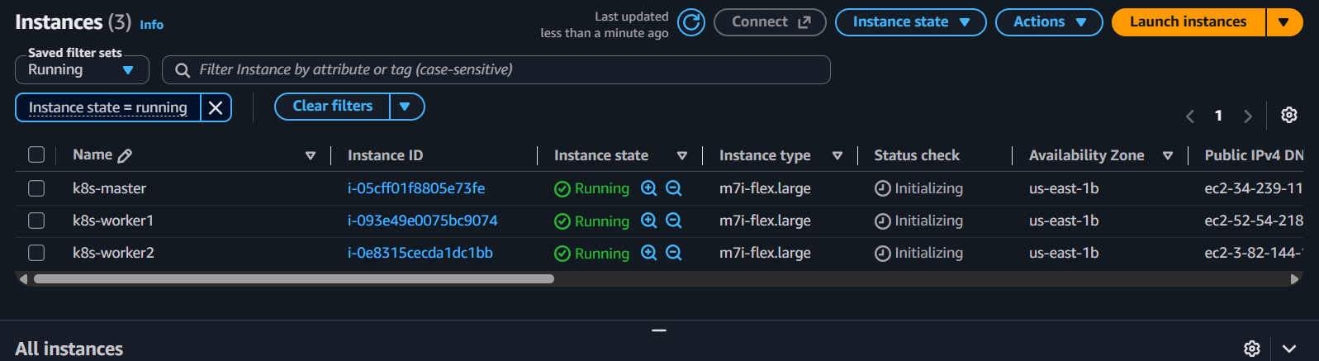

Step 2 — Connect to Control Plane
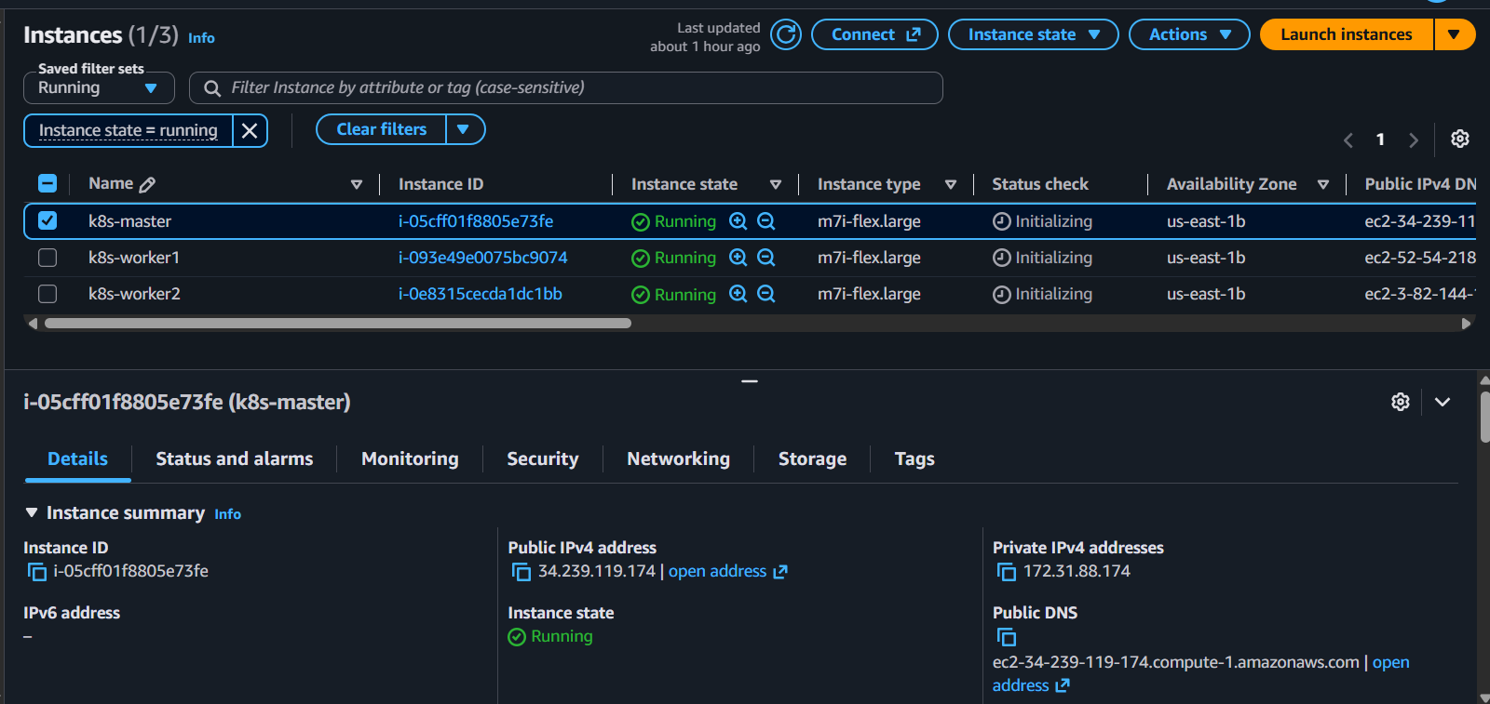
SSH into the first Ubuntu machine:
ssh -i <key.pem> ubuntu@<CONTROL_PLANE_PUBLIC_IP>

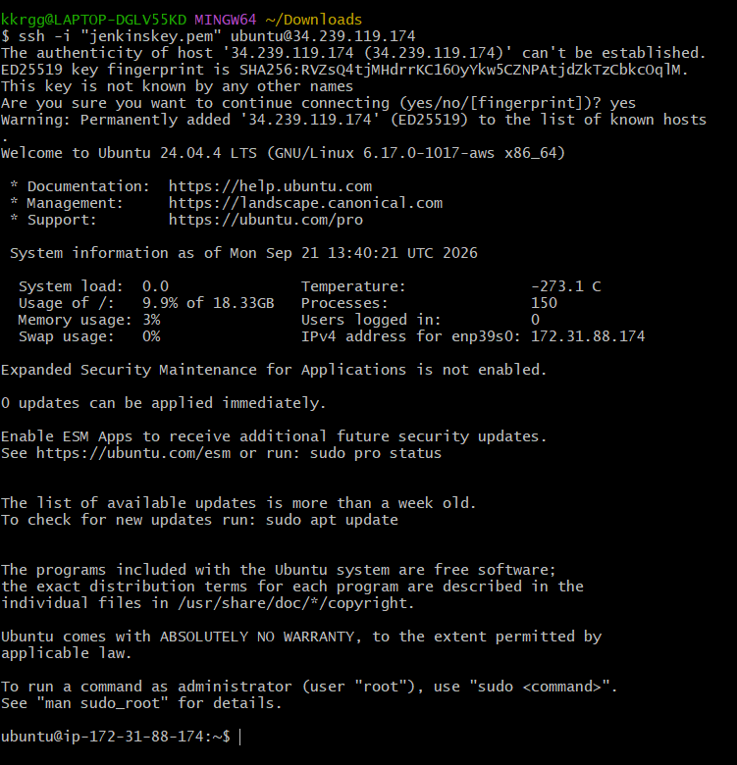
Check:
hostname
Set hostname:
sudo hostnamectl set-hostname k8s-master
Reconnect or run:
exec bash
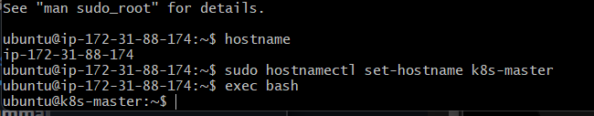

Step 3 — Configure Worker 1
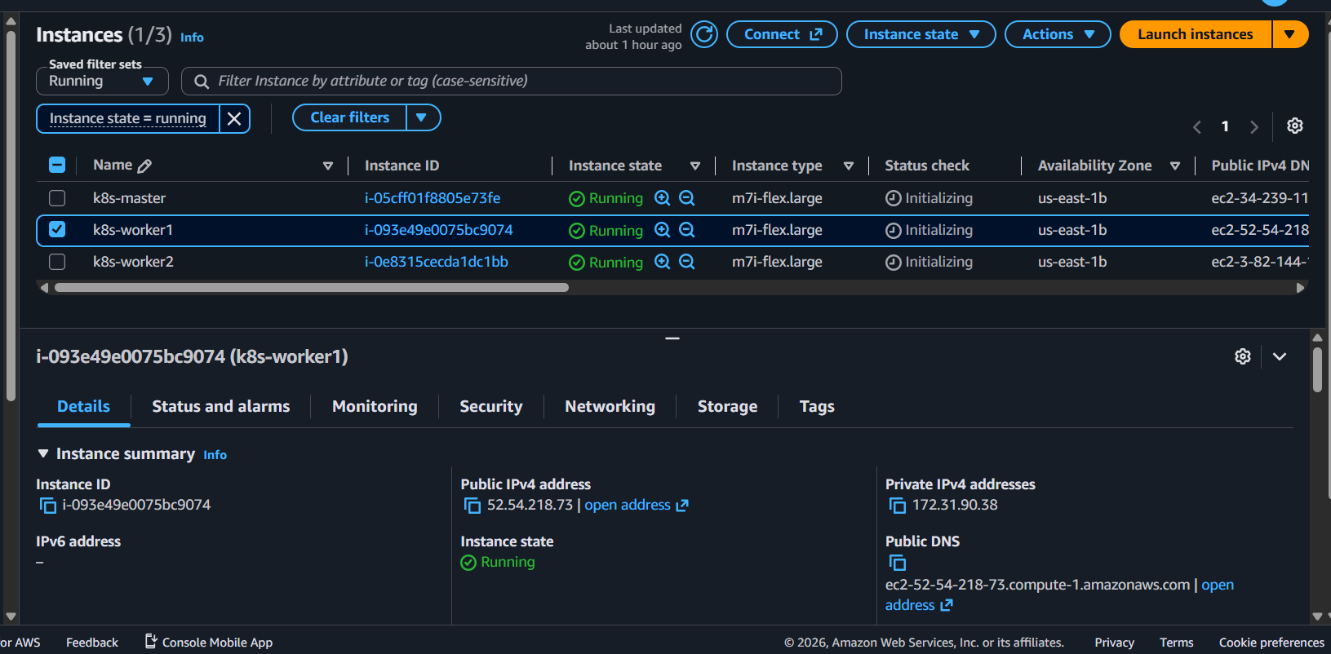
SSH into Worker 1:
ssh -i <key.pem> ubuntu@<WORKER1_PUBLIC_IP>
Run:
sudo hostnamectl set-hostname k8s-worker1
Reconnect:
exec bash

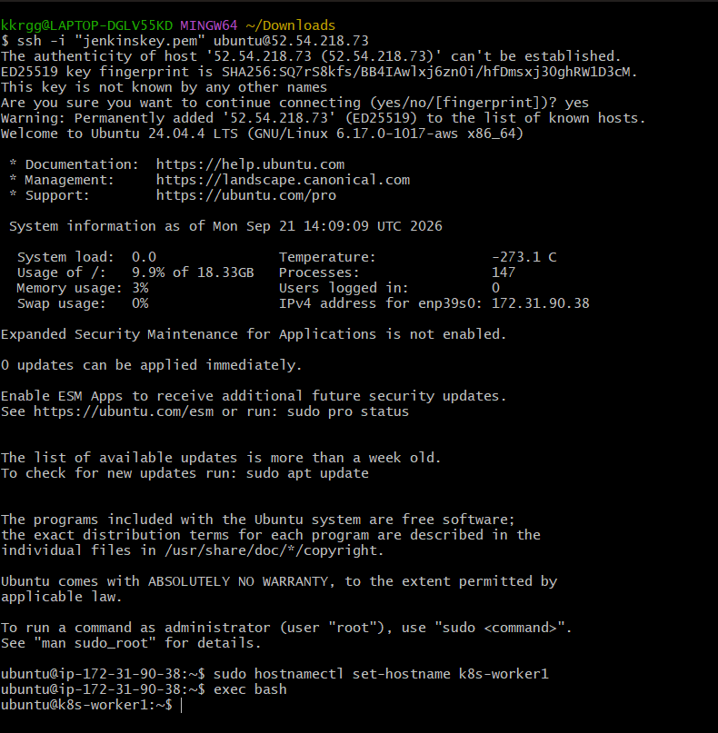

Step 4 — Configure Worker 2
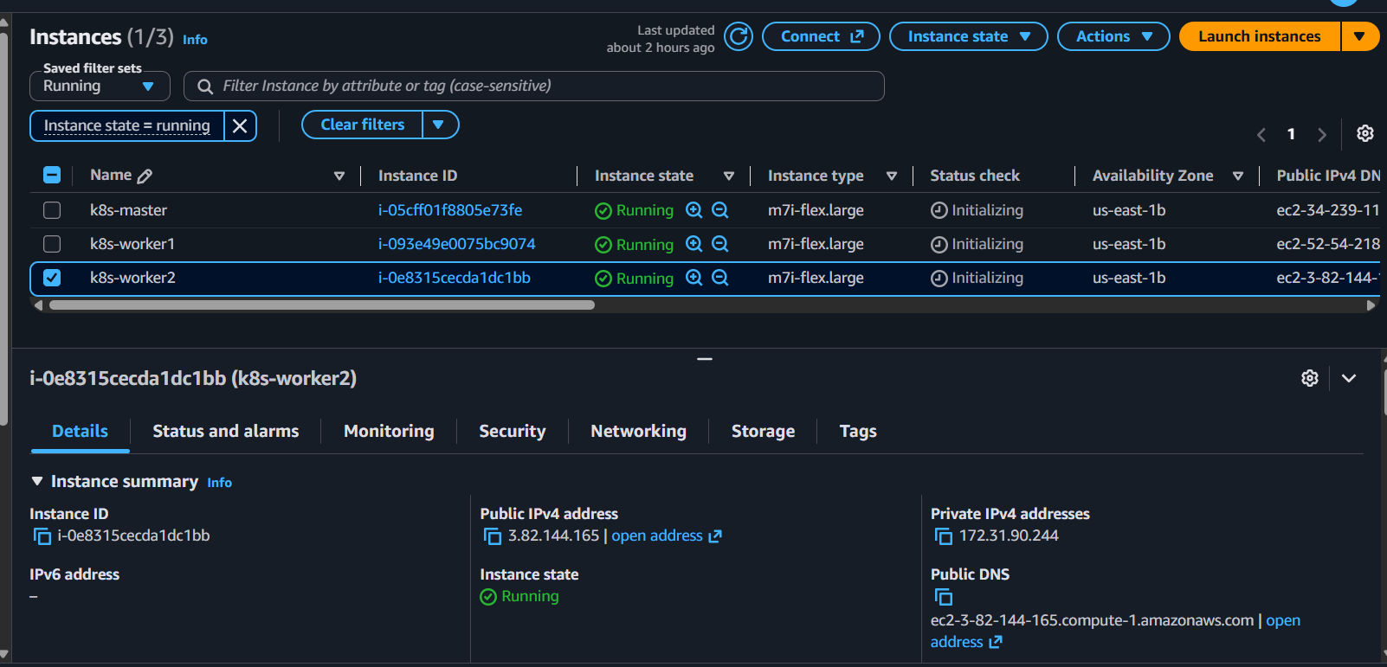
SSH into Worker 2:
ssh -i <key.pem> ubuntu@<WORKER2_PUBLIC_IP>
Run:
sudo hostnamectl set-hostname k8s-worker2
Reconnect:
exec bash
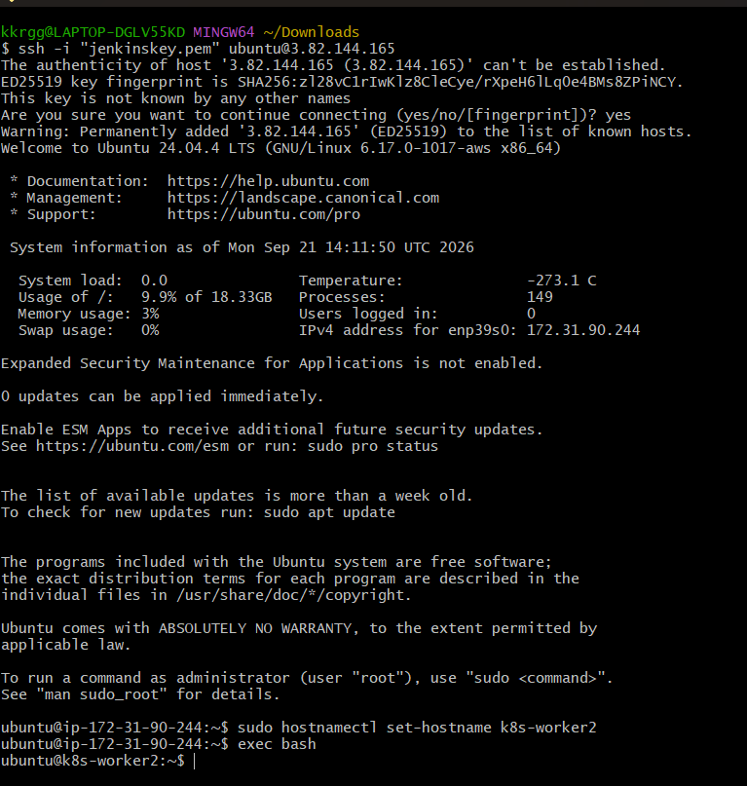

Step 5 — Update All 3 Machines
Run this on Control Plane, Worker 1 and Worker 2:
sudo apt update
sudo apt upgrade -y

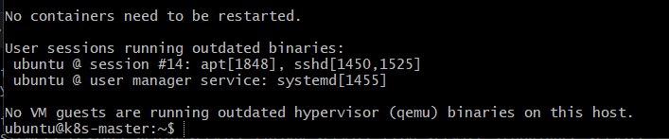
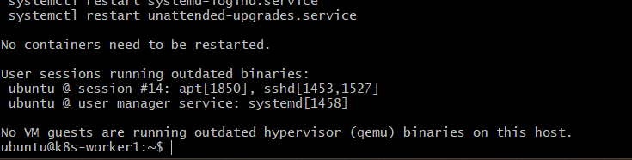

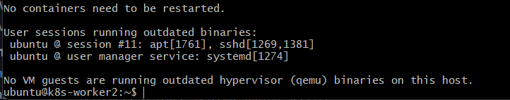

Step 6 — Disable Swap
Run on all 3 machines:
sudo swapoff -a
Disable it permanently:
sudo sed -i '/ swap / s/^/#/' /etc/fstab
Verify:
free -h
Swap should be 0.
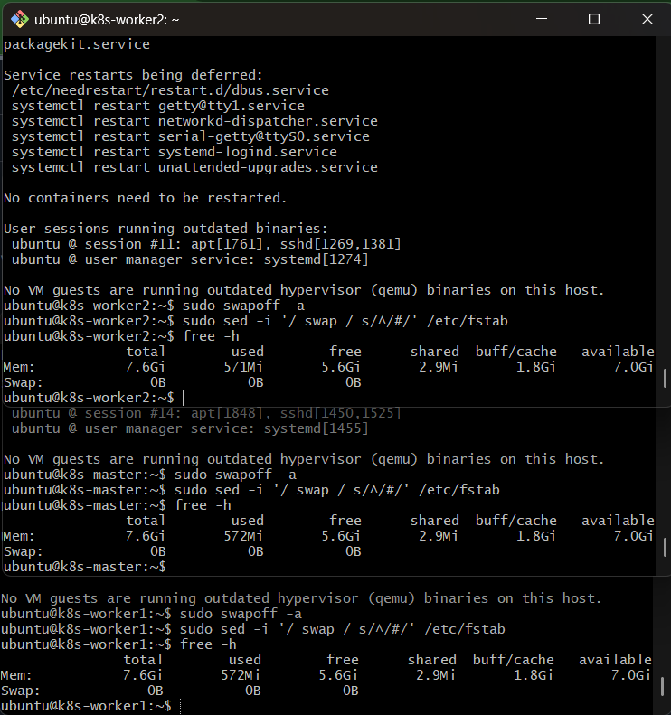

Step 7 — Install containerd
Run on all 3 machines:
sudo apt install -y containerd
Create configuration:
sudo mkdir -p /etc/containerd
containerd config default | sudo tee /etc/containerd/config.toml
Enable systemd cgroups:
sudo sed -i 's/SystemdCgroup = false/SystemdCgroup = true/' /etc/containerd/config.toml
Restart:
sudo systemctl restart containerd
Enable at boot:
sudo systemctl enable containerd
Verify:
sudo systemctl status containerd
You should see:
active (running)

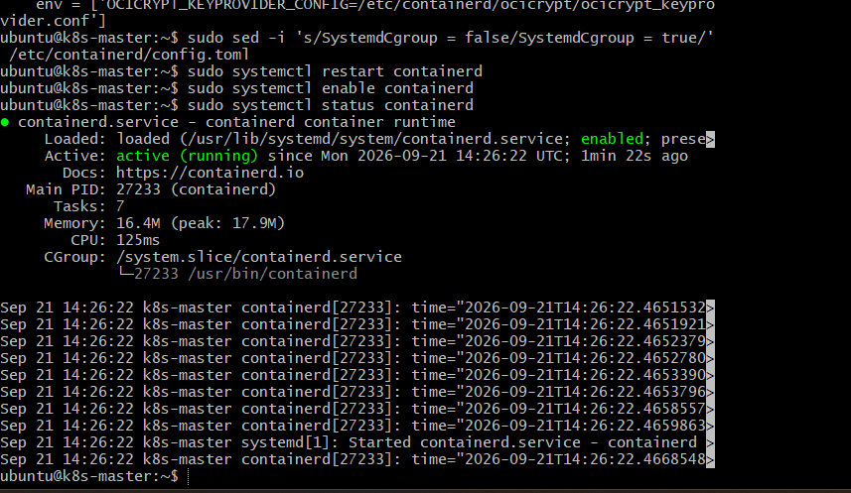

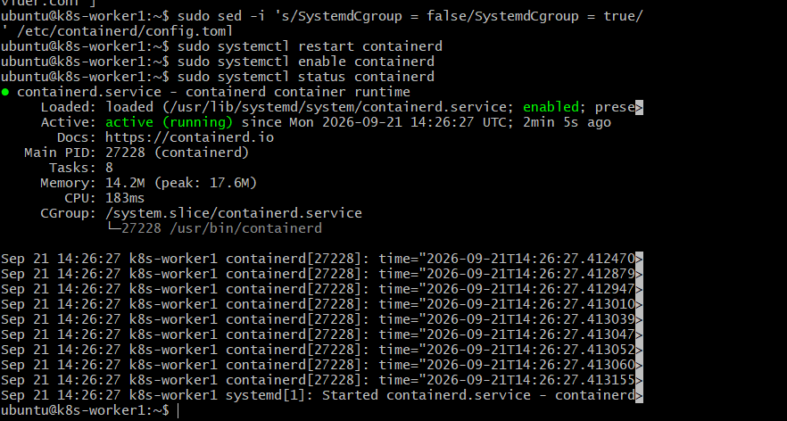

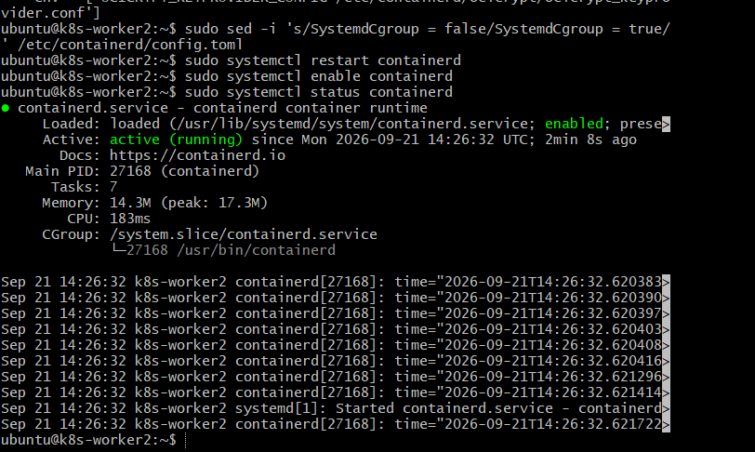

Step 8 — Install Kubernetes Packages
Do this on all 3 machines.
Install required packages:
sudo apt install -y apt-transport-https ca-certificates curl gpg
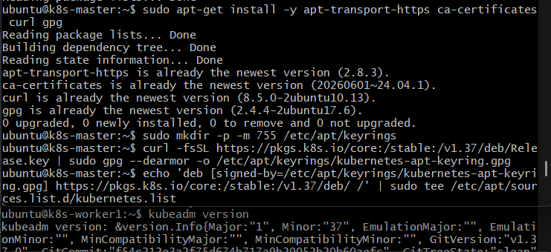

Add the current Kubernetes package repository and install:
kubelet
kubeadm
kubectl
Use the current official Kubernetes installation instructions for the repository because the repository/version path changes over time.
After installation, verify:
kubeadm version
kubectl version --client
kubelet –version

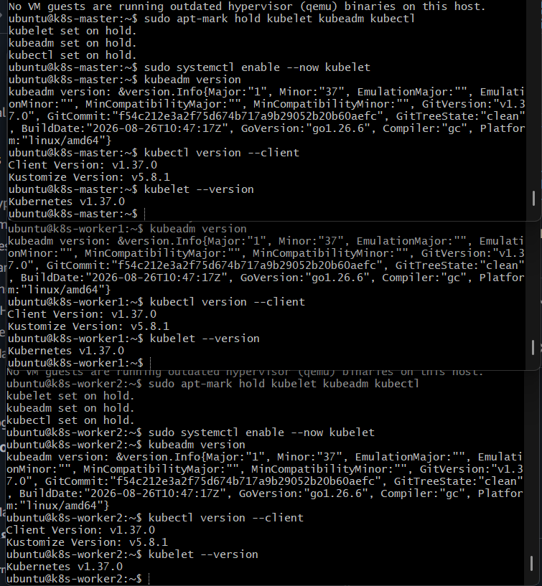

Step 9 — Initialize the Control Plane
Do this ONLY on k8s-master.
Find its private IP:
ip addr
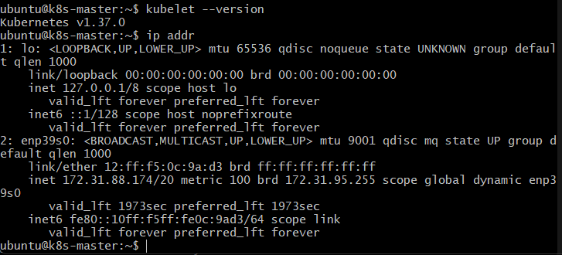
Then initialize Kubernetes:
sudo kubeadm init --apiserver-advertise-address=<CONTROL_PLANE_PRIVATE_IP> --pod-network-cidr=192.168.0.0/16
Example:
sudo kubeadm init --apiserver-advertise-address=10.0.1.10 --pod-network-cidr=192.168.0.0/16
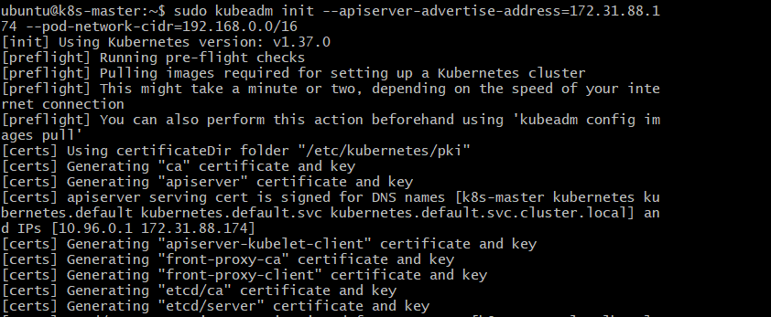
At the end, you will receive a kubeadm join command.
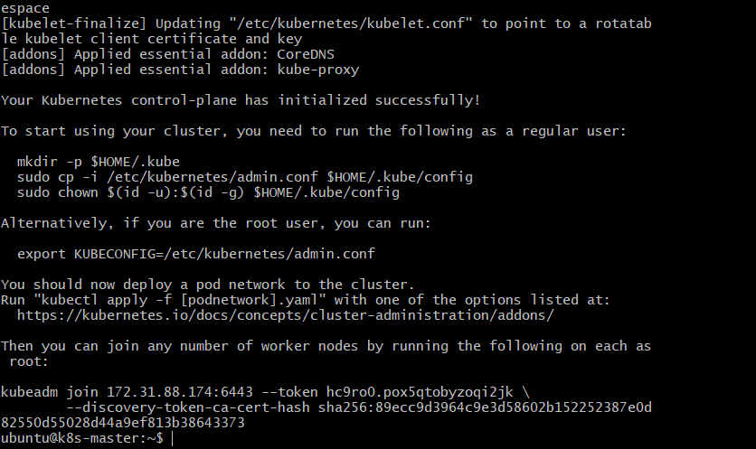
It will look similar to:
sudo kubeadm join <CONTROL_PLANE_PRIVATE_IP>:6443 \
--token <TOKEN> \
--discovery-token-ca-cert-hash sha256:<HASH>

⚠️ Save this command.
You need it for both workers.
kubeadm join 172.31.88.174:6443 --token hc9ro0.pox5qtobyzoqi2jk \
--discovery-token-ca-cert-hash sha256:89ecc9d3964c9e3d58602b152252387e0d82550d55028d44a9ef813b38643373

Step 10 — Configure kubectl on Control Plane
Still on k8s-master:
mkdir -p $HOME/.kube
sudo cp -i /etc/kubernetes/admin.conf $HOME/.kube/config
sudo chown $(id -u):$(id -g) $HOME/.kube/config
Check:
kubectl get nodes
At this point the Control Plane may show:
NotReady
That is expected because we haven't installed the Pod network yet.
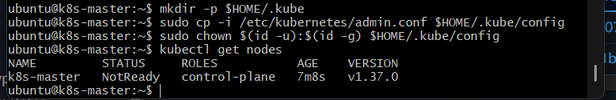

Step 11 — Install Pod Network
On the Control Plane, install a Kubernetes CNI such as Calico using its current official installation instructions.
After installation:
kubectl get pods -A
Wait for the networking components to become ready.
Then:
kubectl get nodes
The Control Plane should become:
k8s-master Ready
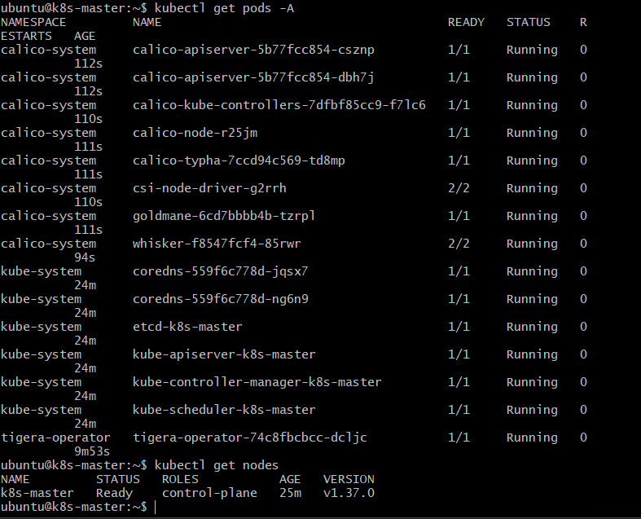

Step 12 — Join Worker 1
Go to k8s-worker1.
Run the exact kubeadm join command generated in Step 9.
Example:
sudo kubeadm join 10.0.1.10:6443 \
--token <TOKEN> \
--discovery-token-ca-cert-hash sha256:<HASH>
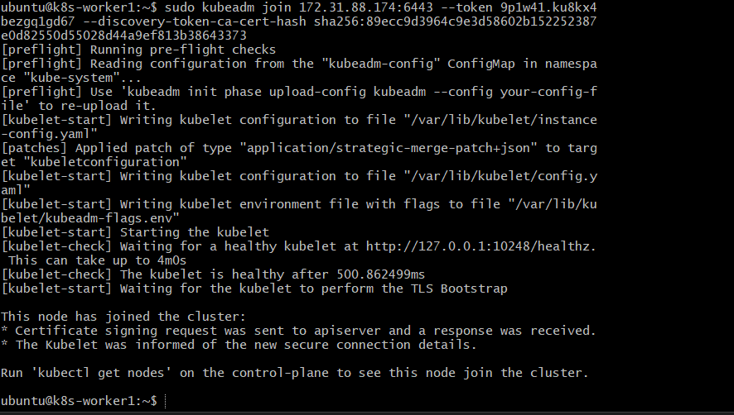

Step 13 — Join Worker 2
Go to k8s-worker2.
Run the same kubeadm join command:
sudo kubeadm join 10.0.1.10:6443 \
--token <TOKEN> \
--discovery-token-ca-cert-hash sha256:<HASH>

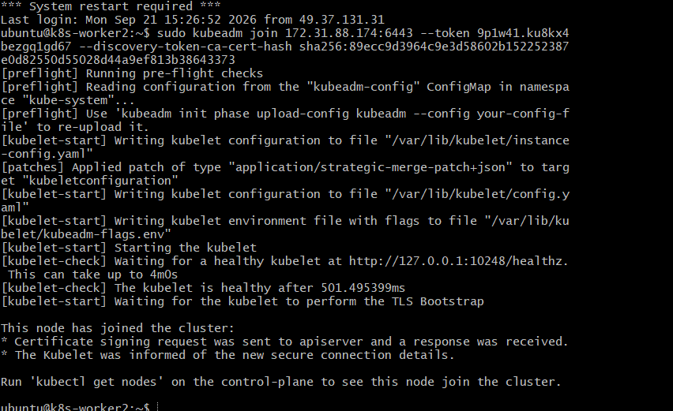

Step 14 — Final Validation
Go back to Control Plane.
Run:
kubectl get nodes
Expected:
NAME STATUS ROLES AGE
k8s-master Ready control-plane ...
k8s-worker1 Ready <none> ...
k8s-worker2 Ready <none> ...
Then:
kubectl get pods -A
All required Kubernetes system Pods should eventually show Running or an appropriate completed/ready state.
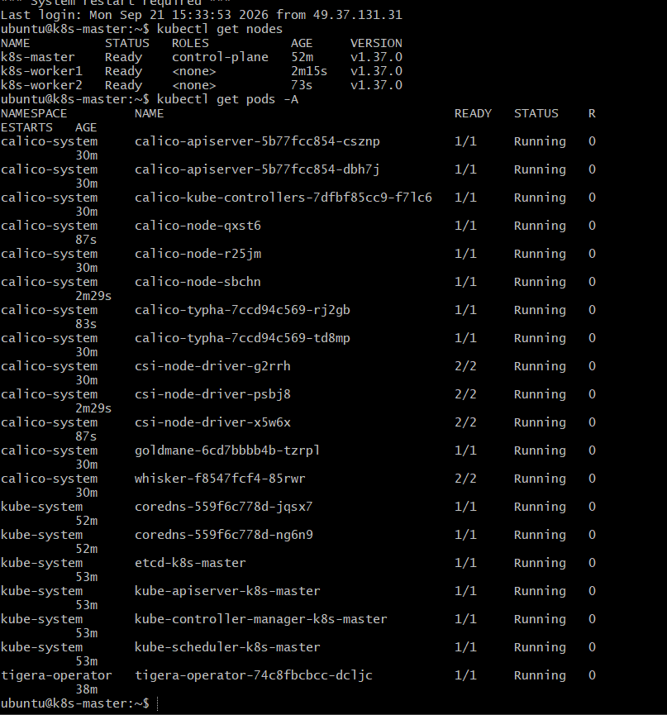

Task 2 Outcome
You have now created:
Kubernetes Cluster
|
k8s-master
Control Plane
|
+------------+------------+
| |
k8s-worker1 k8s-worker2
Worker Worker

Task 2 is complete when:
[ ] 3 Ubuntu machines created
[ ] Hostnames configured
[ ] Swap disabled
[ ] containerd installed
[ ] kubeadm installed
[ ] kubelet installed
[ ] kubectl installed
[ ] Control Plane initialized
[ ] CNI installed
[ ] Worker 1 joined
[ ] Worker 2 joined
[ ] All 3 nodes show Ready

Task 3 — Run One NGINX Pod

Objective
Deploy a single NGINX Pod in the Kubernetes cluster and verify that it is running.

Step 3.1 — Create NGINX Pod
Run this on the master:
kubectl run nginx --image=nginx

Step 3.2 — Check Pod
kubectl get pods
Expected:
NAME READY STATUS RESTARTS AGE
nginx 1/1 Running 0 ...
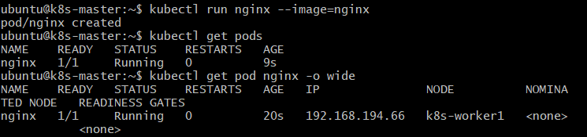

Step 3.3 — Check Which Node Runs the Pod
kubectl get pod nginx -o wide
You should see the NGINX Pod assigned to one of your worker nodes.

Step 3.4 — Check Pod Details
kubectl describe pod nginx
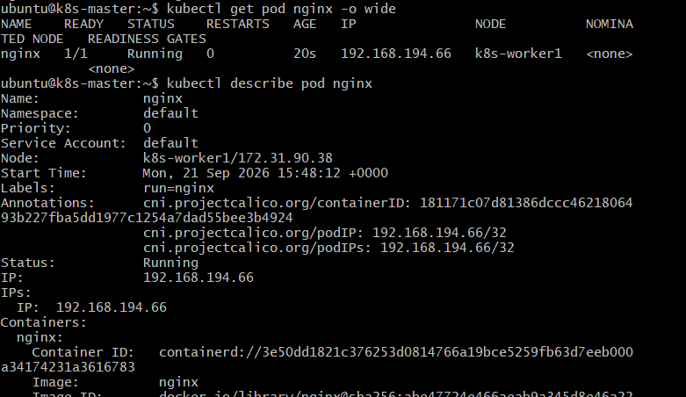

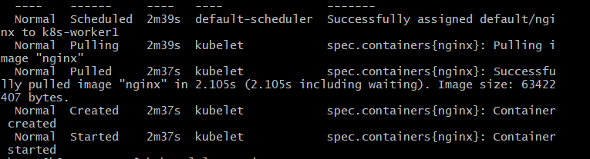

Step 3.5 — Check NGINX Logs
kubectl logs nginx
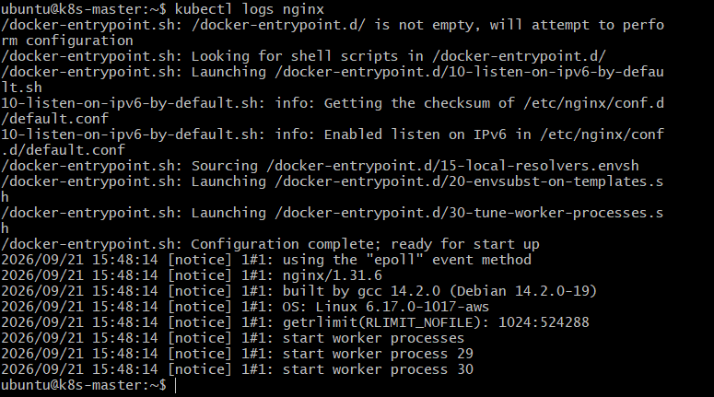

Expected Outcome
You have successfully:
Created and verified one NGINX Pod running inside the Kubernetes cluster.

Task 4 — Learn Kubernetes Components

Objective
Understand the major Control Plane and Worker Node components and their responsibilities.

4.1 Control Plane Components
Component | Purpose
kube-apiserver | Entry point for all Kubernetes API requests
etcd | Stores Kubernetes cluster state and configuration
kube-scheduler | Decides which worker node should run a new Pod
kube-controller-manager | Ensures the actual cluster state matches the desired state

4.2 Worker Node Components
Component | Purpose
kubelet | Communicates with the API server and ensures Pods are running
kube-proxy | Handles network communication and Service traffic
Container Runtime | Runs containers; in your cluster this is containerd

4.3 Simple Flow
CONTROL PLANE
┌──────────────────────────┐
│ kube-apiserver │
│ │ │
│ ┌────┴────┐ │
│ etcd scheduler │
│ │ │
│ controller-manager │
└───────────┬──────────────┘
│
┌─────────┴─────────┐
│ │
WORKER NODE 1 WORKER NODE 2
┌────────────┐ ┌────────────┐
│ kubelet │ │ kubelet │
│ kube-proxy │ │ kube-proxy │
│ containerd │ │ containerd │
│ Pods │ │ Pods │
└────────────┘ └────────────┘

